CREDIT CARD FRAUD DETECTION USING MACHINE LEARNING AND DEEP LEARNING

Project Report

Submitted By:
Erum Romesa
Shehneela
Eman

Degree:
BS Computer Science
BS Computer Engineering

Submitted To:
Team Buraaq x Innoverse

Submission Date:
10 June 2026

Instructor:
Mam Iqra Akhtar

AI Fusion Bootcamp Internship 2026

Abstract
Credit card fraud has become a significant challenge for financial institutions due to the increasing volume of digital transactions. This project presents a fraud detection system using Machine Learning and Deep Learning techniques. A credit card transaction dataset containing 555,719 records was preprocessed through feature engineering, label encoding, normalization, and standardization. Three models, namely Random Forest, Gradient Boosting, and a Deep Learning Neural Network, were trained and evaluated. Performance was assessed using confusion matrices, classification reports, ROC curves, histograms, and radar charts. Experimental results showed that Random Forest achieved the highest AUC score of 0.9277, while Gradient Boosting achieved better fraud recall. The Deep Learning model performed poorly due to class imbalance. The proposed system also includes a Flask-based backend and a web-based frontend interface. The study demonstrates the effectiveness of ensemble learning methods for fraud detection and highlights challenges associated with highly imbalanced datasets.
Keywords:
Credit Card Fraud Detection, Machine Learning,
Random Forest, Gradient Boosting,
Deep Learning, Classification, Fraud Analytics

Introduction
This project aims to detect fraudulent credit card transactions using Machine Learning and Deep Learning techniques. The dataset was preprocessed, analyzed, and used to train Random Forest, Gradient Boosting, and Deep Learning models. The performance of each model was evaluated using classification reports, confusion matrices, and ROC curves.

Contribution
The major contributions of this work are:
- Development of a fraud detection framework using Machine Learning and Deep Learning.
- Feature engineering through extraction of temporal and demographic attributes.
- Comparative evaluation of Random Forest, Gradient Boosting, and Neural Networks.
- Visualization of model performance using ROC curves and confusion matrices.
- Deployment of the trained model using Flask backend and web frontend technologies.

Literature Review
Credit card fraud detection has been widely studied using statistical, machine learning, and deep learning approaches. Researchers have explored ensemble learning methods, neural networks, anomaly detection, and hybrid frameworks to improve fraud detection performance on highly imbalanced transaction datasets.
Paper 1
Mienye and Jere (2024) applied deep learning methods for credit card fraud detection due to their robustness and efficient performance. The study utilized several datasets, including the European Credit Card Dataset, Brazilian Credit Card Dataset, IEEE-CIS Fraud Detection Dataset, and PaySim Synthetic Dataset. Model performance was evaluated using confusion matrices and other classification metrics. The authors discussed suitable performance measures, challenges encountered when applying deep learning architectures, and potential solutions to these challenges. The study demonstrated that the use of real-world datasets helps evaluate the robustness and effectiveness of deep learning models for credit card fraud detection.
Paper 2
Khalid, Owoh, Uthmani, Ashawa, Osamor, and Adejoh (2024) investigated the application of Machine Learning techniques for credit card fraud detection, with a particular focus on ensemble learning methods. The study evaluated several classifiers, including Support Vector Machine (SVM), K-Nearest Neighbor (KNN), Random Forest (RF), Bagging, and Boosting models. To address the issue of class imbalance, the Synthetic Minority Oversampling Technique (SMOTE) was applied before model training. The authors reported that ensemble-based models outperformed traditional machine learning approaches in terms of accuracy, precision, recall, and F1-score. The study highlighted the effectiveness of ensemble learning combined with data balancing techniques for improving fraud detection performance.

Paper 3
Alarfaj, Malik, Khan, Al Musallam, Ramzan, and Ahmed (2022) conducted a comparative study of Machine Learning and Deep Learning approaches for credit card fraud detection. The study addressed major challenges such as public data accessibility, class imbalance, changing fraud patterns, and high false alarm rates. Using the European Credit Card Dataset, the authors evaluated several machine learning algorithms and proposed three Convolutional Neural Network (CNN) architectures for fraud detection. A comprehensive empirical analysis was performed by varying the number of hidden layers and training epochs. The results demonstrated that the proposed CNN-based model achieved superior performance with an accuracy of 99.9%, precision of 93%, F1-score of 85.71%, and AUC of 98%. The study highlighted the effectiveness of deep learning techniques in reducing fraud losses and improving real-world credit card fraud detection systems.

Paper 4
El Hlouli, Riffi, Mahraz, Yahyaouy, El Fazazy, and Tairi (2024) proposed a hybrid deep learning framework for credit card fraud detection to address the challenges posed by highly imbalanced datasets. The study combined Autoencoders (AE), Fully Connected Deep Networks (FCDN), and the Synthetic Minority Oversampling Technique (SMOTE) to improve fraud detection performance. The proposed approach consisted of multiple phases, including fraud-specific feature learning, dimensionality reduction, and classification using deep neural networks. The authors evaluated the model using accuracy, precision, recall, and F1-score metrics. Experimental results demonstrated that the integrated AE–FCDN architecture achieved robust and accurate fraud detection performance. The study highlighted the effectiveness of combining deep learning techniques with data balancing methods to enhance financial security and reduce losses caused by fraudulent transactions.
Paper 5
Hamdan and Manjaiah (2021) proposed a deep learning-based anomaly detection model for identifying fraudulent credit card transactions. The study addressed the growing global problem of credit card fraud, which causes significant financial losses to customers, businesses, and financial institutions. The proposed model was evaluated using a European credit card transaction dataset collected over two days in September 2013 and was compared with several existing machine learning algorithms. Accuracy was used as the primary evaluation metric to assess the model’s fraud detection capability. The experimental results demonstrated the effectiveness of deep learning techniques for anomaly detection and highlighted their potential for improving the security and reliability of financial transaction systems.
Paper 6
Esenogho, Mienye, Swart, Aruleba, and Obaido (2022) proposed a credit card fraud detection framework based on a Long Short-Term Memory (LSTM) neural network ensemble classifier and a hybrid data resampling technique. The study addressed the challenges of highly imbalanced datasets and the inability of traditional machine learning algorithms to adapt to dynamic customer spending behavior. The proposed approach combined LSTM with the AdaBoost ensemble technique and employed the SMOTE-ENN hybrid resampling method to balance the dataset. The model was evaluated using real-world credit card transaction datasets and compared with Support Vector Machine (SVM), Multilayer Perceptron (MLP), Decision Tree, traditional AdaBoost, and standalone LSTM models. Experimental results showed that the proposed LSTM ensemble achieved superior performance with a sensitivity of 0.996 and specificity of 0.998, outperforming all benchmark algorithms. The study demonstrated the effectiveness of combining deep learning, ensemble learning, and data balancing techniques for accurate credit card fraud detection.
Paper 7
Zhang, Lu, Lin, Qiao, and Zheng (2022) investigated credit card fraud detection using anomaly detection techniques on highly imbalanced datasets. The study addressed the limitations of traditional classifiers and conventional balancing methods, such as SMOTE, in detecting rare fraudulent transactions. The authors proposed a hybrid approach that combined Isolation Forest (IForest) with Kernel Principal Component Analysis (KPCA) and employed a One-Class Support Vector Machine (OCSVM) integrated with AdaBoost for outlier detection. The proposed model was evaluated using accuracy, precision, recall, and F1-score metrics. Experimental results demonstrated excellent performance, achieving 96% accuracy, 100% precision, 96% recall, and 98% F1-score. The study highlighted the effectiveness of anomaly detection and ensemble learning techniques in improving fraud detection accuracy and handling imbalanced credit card transaction datasets.
Paper 8
Singh and Jain (2022) proposed a cost-sensitive weak learner approach with Bagging and Random Forest classifiers (CSWLB) for credit card fraud detection on highly imbalanced datasets. The study aimed to reduce misclassification errors and improve fraud detection performance by assigning higher weights to fraudulent transactions through cost-sensitive learning. The proposed framework combined cost-sensitive classification, Bagging ensembles, and Random Forest classifiers to enhance prediction accuracy. The model was evaluated using the Brazilian credit card dataset and compared with various sampling, cost-sensitive, and machine learning techniques. Experimental results showed that the proposed CSWLB approach achieved an accuracy of 97.361% with a total cost of 765, outperforming existing methods. The study demonstrated that integrating cost-sensitive learning with ensemble techniques can effectively address class imbalance and improve credit card fraud detection performance.
Paper 9
Raj and Portia (2011) presented a comprehensive survey of credit card fraud detection techniques in response to the increasing use of credit cards and the rapid growth of e-commerce. The study reviewed various fraud detection approaches, including Artificial Intelligence, Data Mining, Fuzzy Logic, Machine Learning, Sequence Alignment, and Genetic Programming techniques. The authors analyzed and compared these methods based on different design criteria to evaluate their effectiveness in detecting fraudulent transactions. The survey highlighted the strengths and limitations of existing fraud detection mechanisms and emphasized the need for more efficient and adaptive fraud detection systems. The study provides valuable insights into the evolution of fraud detection techniques and serves as a foundation for future research in credit card fraud prevention.
Paper 10
Sulaiman, Schetinin, and Sant (2022) conducted a comparative review of machine learning techniques for credit card fraud detection and data confidentiality. The study examined various machine learning approaches used to detect fraudulent transactions while addressing privacy concerns associated with financial data. Based on the analysis of existing literature, the authors proposed a hybrid solution that integrates Artificial Neural Networks (ANN) within a Federated Learning framework. The proposed approach aims to improve fraud detection accuracy while preserving the privacy of customer information by enabling decentralized model training. The findings suggested that combining ANN with Federated Learning can provide an effective and privacy-preserving solution for credit card fraud detection. The study highlighted the importance of balancing detection performance and data security in modern fraud detection systems.
Paper 11
Raghavan and El Gayar (2019) conducted a benchmarking study of various Machine Learning and Deep Learning techniques for credit card fraud detection. The research compared machine learning algorithms, including K-Nearest Neighbor (KNN), Random Forest, and Support Vector Machine (SVM), with deep learning methods such as Autoencoders, Convolutional Neural Networks (CNN), Restricted Boltzmann Machines (RBM), and Deep Belief Networks (DBN). The study utilized European, Australian, and German credit card datasets to evaluate the effectiveness of these approaches. Performance was assessed using Area Under the ROC Curve (AUC), Matthews Correlation Coefficient (MCC), and Cost of Failure metrics. The comparative analysis provided insights into the strengths and weaknesses of both machine learning and deep learning models in detecting fraudulent transactions. The study highlighted the importance of selecting appropriate algorithms and evaluation metrics for developing reliable credit card fraud detection systems.
Paper 12
Gandhar, Gupta, Panday, and Raj (2024) presented a comprehensive review of Machine Learning (ML) and Deep Learning (DL) techniques for fraud detection. The study examined various approaches, including supervised learning, unsupervised learning, and reinforcement learning, and analyzed their strengths and limitations in detecting fraudulent activities. The authors discussed major challenges in fraud detection, such as imbalanced datasets, adversarial attacks, model interpretability, and the importance of feature engineering and data preprocessing. A case study from the financial sector was also presented to demonstrate the practical application of ML and DL techniques in identifying fraudulent transactions while maintaining high precision and scalability. The review highlighted the effectiveness of modern ML and DL methods in reducing false positives and improving fraud detection performance. The study provides valuable insights into current advancements and future research directions in fraud detection systems.
Paper 13
Benchaji, Douzi, El Ouahidi, and Jaafari (2021) proposed a novel credit card fraud detection system based on sequential data modeling using Long Short-Term Memory (LSTM) networks and an attention mechanism. The study addressed the growing challenge of fraudulent credit card transactions by considering the sequential nature of transaction data rather than treating transactions independently. The proposed framework combined Uniform Manifold Approximation and Projection (UMAP) for feature selection, LSTM networks for capturing transaction sequences, and an attention mechanism to identify the most significant transactions contributing to fraud detection. Experimental evaluations demonstrated strong performance in terms of efficiency and effectiveness compared to traditional approaches. The results indicated that incorporating sequential transaction patterns and attention-based learning improved the model’s ability to accurately detect fraudulent activities. The study highlighted the potential of advanced deep learning architectures for enhancing credit card fraud detection systems.
Paper 14
Bhattacharyya, Jha, Tharakunnel, and Westland (2011) investigated the application of data mining techniques for credit card fraud detection using real-world transaction data from an international credit card operation. The study evaluated the performance of Support Vector Machines (SVM), Random Forests, and Logistic Regression in identifying fraudulent transactions. The authors aimed to improve fraud detection accuracy and support financial institutions in controlling and preventing credit card fraud. Experimental results demonstrated that advanced data mining approaches, particularly ensemble learning methods, were effective in distinguishing fraudulent transactions from legitimate ones. The comparative analysis provided valuable insights into the strengths and limitations of different classification techniques for fraud detection. The study highlighted the potential of machine learning-based data mining methods for enhancing the efficiency and reliability of credit card fraud detection systems.
Paper 15
Dal Pozzolo, Boracchi, Caelen, Alippi, and Bontempi (2018) addressed the challenges of credit card fraud detection in real-world financial environments by focusing on issues such as class imbalance, concept drift, and verification latency. The study proposed a realistic formalization of the fraud detection problem based on the operational conditions of fraud detection systems that continuously analyze large streams of credit card transactions. The authors developed a novel learning strategy designed to handle evolving customer behavior, changing fraud patterns, and delayed verification of suspicious transactions. The proposed approach was evaluated using a real-world dataset containing more than 75 million transactions collected over a three-year period. Experimental results demonstrated the significant impact of class imbalance and concept drift on fraud detection performance and highlighted the importance of using appropriate evaluation metrics. The study provided valuable insights into designing robust and realistic fraud detection systems capable of operating effectively in dynamic financial environments.
Paper 16
Patni, Manoj, Vamisdhar, Aravind, Reddy, Jaswant, and Panday (2025) examined the application of machine learning techniques for credit card fraud detection in the digital era. The study emphasized the growing importance of fraud detection systems due to the increasing volume of online financial transactions and evolving fraud threats. Various machine learning and deep learning algorithms were analyzed based on their applicability, scalability, and interpretability in detecting fraudulent activities. The research included a comparative study of advanced deep learning approaches such as Convolutional Neural Networks (CNNs) and Recurrent Neural Networks (RNNs) for fraud detection. The findings highlighted the strengths and limitations of different algorithms and provided recommendations for selecting suitable techniques in real-world fraud detection systems. The study contributed to understanding the effectiveness of modern machine learning and deep learning methods in enhancing credit card fraud prevention.
Paper 17
Dharma and Latha (2025) proposed a hybrid Machine Learning approach for credit card fraud detection to address the increasing number of fraudulent transactions associated with e-commerce and online banking. The study utilized a dataset containing 284,807 transactions collected from European cardholders in September 2013. The proposed hybrid model combined Support Vector Machine (SVM) and Logistic Regression (LR) techniques to improve fraud detection performance. The model was evaluated using accuracy, precision, recall, and F1-score metrics. Experimental results showed that the hybrid approach achieved an accuracy of 97%, precision of 96%, recall of 97%, and F1-score of 97%, outperforming several traditional machine learning models. The study demonstrated that integrating multiple machine learning techniques can enhance the effectiveness and reliability of credit card fraud detection systems.
Paper 18
Hemanth, Virat, Rohith, Reddy, Selva, and Senthilpandi (2025) proposed a real-time credit card fraud detection framework using supervised machine learning techniques. The study addressed the increasing challenge of online credit card fraud by analyzing transaction patterns and identifying suspicious activities through a feedback-based detection system. A Logistic Regression model was employed to classify fraudulent and legitimate transactions using a highly imbalanced real-world credit card dataset. To improve model robustness, the authors applied data preprocessing, normalization, encoding, sampling techniques, and Exploratory Data Analysis (EDA) to identify significant fraud-related features. The dataset was divided into training and testing sets to evaluate model performance and prediction capability. The study demonstrated that machine learning-based fraud detection systems can effectively adapt to changing fraud patterns and improve the accuracy of real-time fraud detection in financial transactions.
Paper 19
Al Maari and Abdulnabi (2023) proposed a hybrid machine learning framework for enhancing the security of online credit card transactions and preventing fraudulent activities. The study addressed the increasing risks associated with online financial transactions and the growing threat of unauthorized credit card usage. The proposed model integrated AdaBoost, Logistic Regression, and Random Forest algorithms to distinguish between legitimate and fraudulent transactions. Through a comprehensive training process, the hybrid framework was designed to improve prediction accuracy and enable real-time fraud detection. The authors reported that combining multiple machine learning techniques strengthened the model's ability to identify suspicious transactions and reduce financial losses. The study demonstrated that hybrid machine learning approaches can significantly enhance the security and reliability of credit card fraud detection systems.
Paper 20
Bangera, and Shetty, D'Cunha, Deepthi,reekantha (2025) presented a comprehensive credit card fraud detection framework that combines machine learning algorithms with user-centric applications for real-time fraud prevention. The study analyzed fraudulent transaction patterns using various parameters and employed machine learning techniques such as XGBoost, Decision Tree, and Random Forest. To address the issue of class imbalance, the Synthetic Minority Oversampling Technique (SMOTE) was applied to balance the dataset before model training. Experimental results showed that XGBoost achieved the highest accuracy among all evaluated models. The authors further developed practical fraud detection tools, including a Streamlit-based web application and a Tkinter desktop graphical user interface, both utilizing the trained XGBoost model for instant fraud prediction. The study demonstrated the effectiveness of integrating advanced machine learning algorithms with real-time deployment applications to enhance credit card fraud detection and prevention.

Research Gap
Although numerous studies have applied Machine Learning and Deep Learning techniques for credit card fraud detection, several challenges still remain. Many existing approaches suffer from class imbalance issues, limited real-time deployment capabilities, and high false positive rates. Furthermore, several studies focus only on a single algorithm without providing a comprehensive comparison between traditional Machine Learning and Deep Learning methods. Therefore, this study aims to compare Random Forest, Gradient Boosting, and Deep Learning models on a fraud detection dataset while also developing a deployable fraud detection system using Flask and a web-based frontend interface.
Proposed Methodology

Dataset Information
The Credit Card Fraud Detection dataset was used in this study. The dataset contains transaction-related features and a target variable indicating whether a transaction is fraudulent or legitimate.
- Dataset size: 555,719 rows × 23 columns
- Sample used for training: 50,000 rows
- Target variable: is_fraud
The dataset was loaded into Google Colab using Pandas and inspected using df.head(), df.info(), and df.shape() to understand its structure and features.

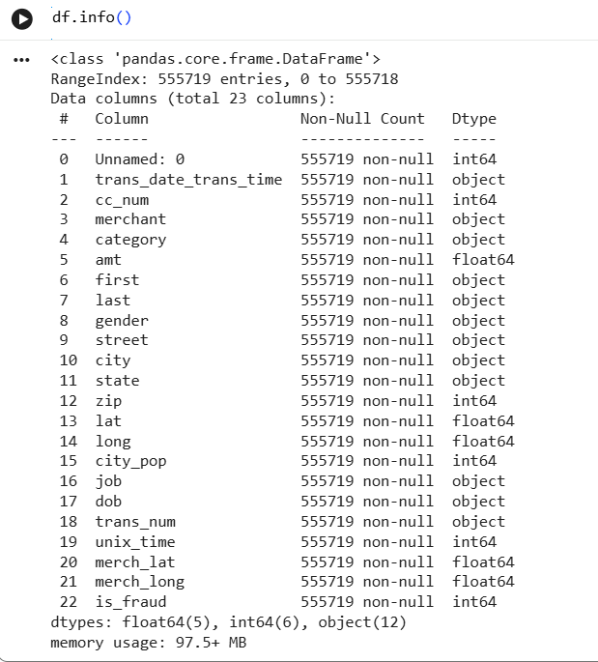

Data Preprocessing
steps performed includes:
- Missing value check
The dataset was checked for missing values using isnull().sum(). No missing value were found, indicating that the dataset was clean and ready for preprocessing.

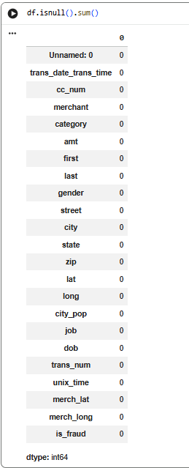

Feature engineering (hour, day, month, age)
New features such as transaction hour, day, month, and customer age were extracted from the transaction date and date of birth columns to improve model performance.

Label encoding
Categorical variables such as merchant, category, gender, city, state, and job were converted into numerical values using Label Encoding so that machine learning algorithms could process them.

Normalization
Min-Max Normalization was applied to scale numerical features b/w 0 and 1.

Standardization
Standardization was performed to transform features to a mean of 0 and standard deviation of 1.

Train-test split (80/20)
The dataset was divided into training and testing sets using an 80:20 ratio to evaluate model performance on unseen data.

Exploratory Data Analysis
- Fraud distribution graph
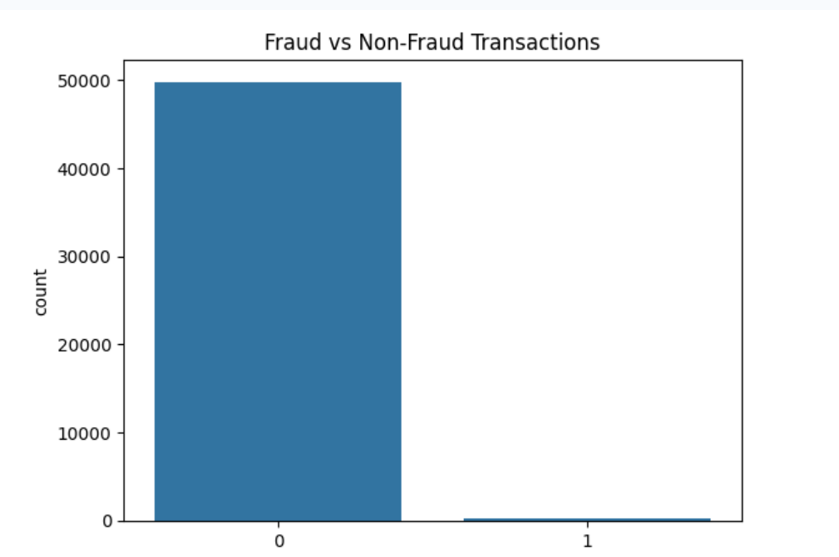
frauddistribution graph shows that the dataset is highly imbalanced. Most transactions belong to the non-fraud class, while only a small percentage are fraudulent. This imbalance makes fraud detection a challenging classification problem.
- Correlation matrix


correlation matrix was used to analyze relationships between numerical features. Strong correlations were observed between geographical features such as latitude and merchant latitude, while most other variables showed weak correlations with the target variable.

Model Training

Random Forest
Random Forest is an ensemble machine learning algorithm that combines multiple decision trees to improve prediction accuracy and reduce overfitting. The model was trained using 100 decision trees.

Gradient Boosting
Gradient Boosting is an ensemble learning technique that builds decision trees sequentially, where each new tree attempts to correct the errors of the previous trees. Gradient Boosting classifier was applied to improve predictive performance through ensemble learning.

Deep Learning Neural Network
A feed-forward neural network was developed using TensorFlow/Keras. The network consisted of an input layer, two hidden layers containing 64 and 32 neurons respectively, and an output layer with one neuron for binary classification.

Results and Discussion
Model Performance Comparison

Model | Precision | Recall | F1 Score | AUC
Random Forest | 1.00 | 0.38 | 0.56 | 0.9277
Gradient Boosting | 0.74 | 0.51 | 0.61 | 0.9058
Deep Learning | 0.00 | 0.00 | 0.00 | 0.5000

Random Forest Results
- Accuracy ≈ 99%
- Recall for fraud class = 0.38
- AUC = 0.9277
Random Forest achieved excellent overall accuracy and AUC performance. However, due to the highly imbalanced nature of the dataset, recall for fraudulent transactions remained moderate.

Gradient Boosting Results

- Recall = 0.51
- AUC = 0.9058
Gradient Boosting achieved better fraud detection recall than Random Forest and demonstrated strong classification performance.

Deep Learning Results

- Accuracy = 99.61%
- AUC = 0.50
Although the deep learning model achieved high overall accuracy, it failed to correctly identify fraudulent transactions because of severe class imbalance. This resulted in poor recall and AUC performance

The experimental results indicate that ensemble learning methods outperformed the Deep Learning model. Random Forest achieved the highest AUC score, while Gradient Boosting demonstrated better fraud recall. The Deep Learning model failed to detect minority fraud cases due to severe class imbalance. These findings suggest that traditional ensemble approaches remain highly effective for tabular fraud detection datasets.

Figure 1: Random Forest Confusion Matrix
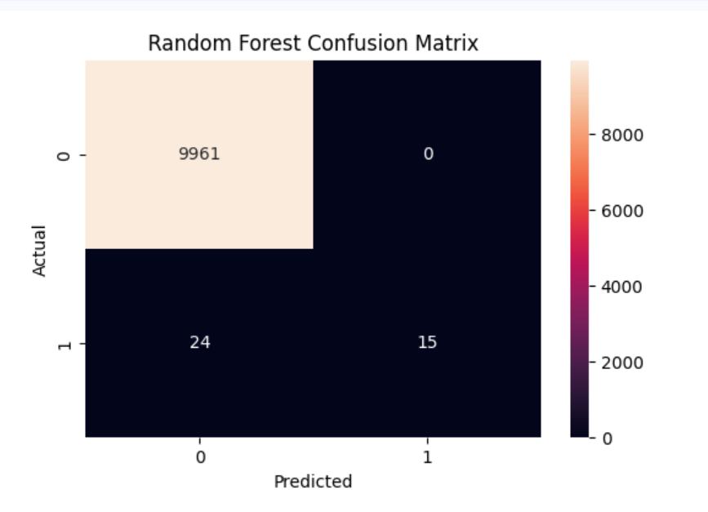

confusion matrix shows the number of correctly and incorrectly classified transactions by the Random Forest model.

Figure 2: Random Forest ROC Curve
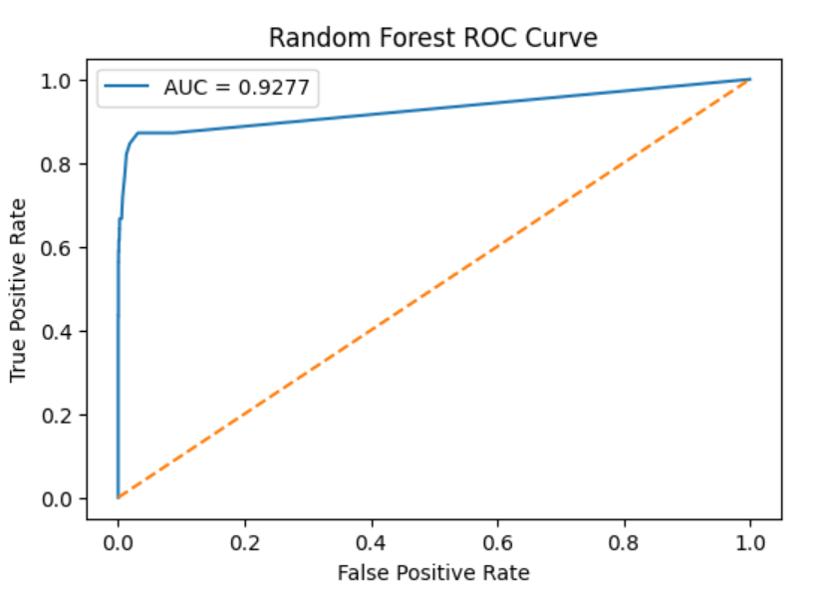

ROC curve evaluates the ability of the Random Forest model to distinguish between fraudulent and non-fraudulent transactions. The model achieved an AUC score of 0.9277.

Figure 3: Gradient Boosting Confusion Matrix
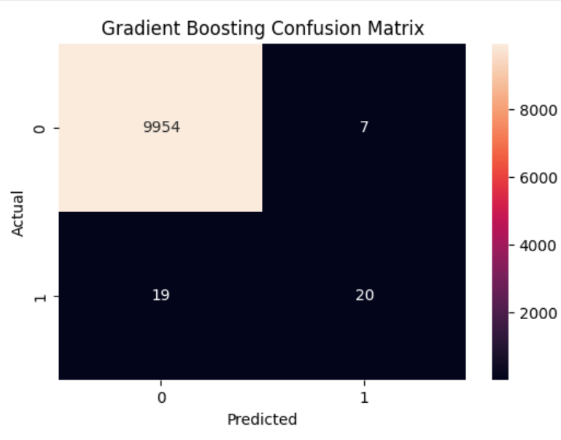
confusion matrix illustrates the classification performance of the Gradient Boosting model.
Figure 4: Gradient Boosting ROC Curve
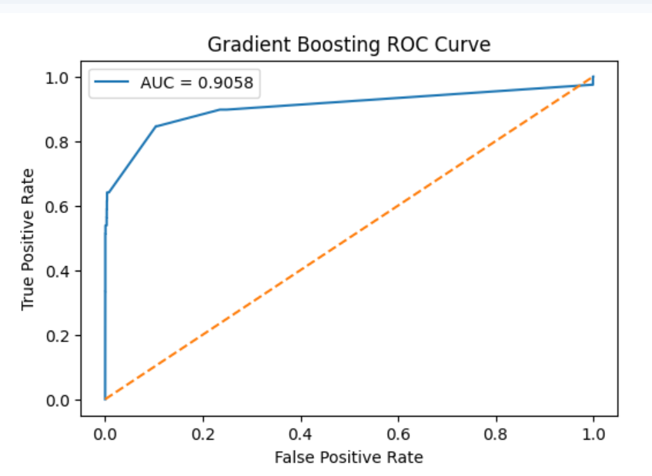
ROCdemonstrates the classification capability of the Gradient Boosting model with an AUC score of 0.9058.

Figure 5:Deep Learning Confusion Matrix
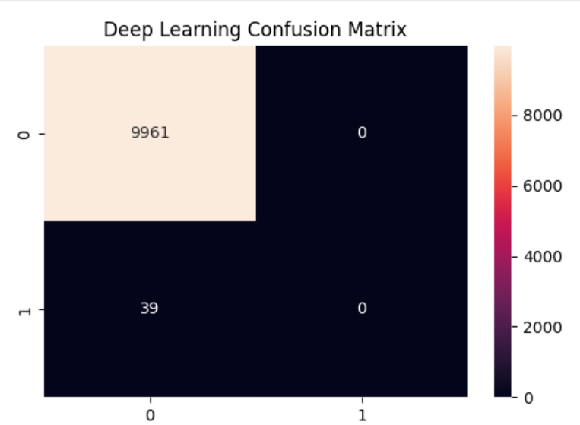
confusion matrix shows that the neural network failed to identify fraudulent transactions due to severe class imbalance.
Figure 6:Deep Learning ROC Curve
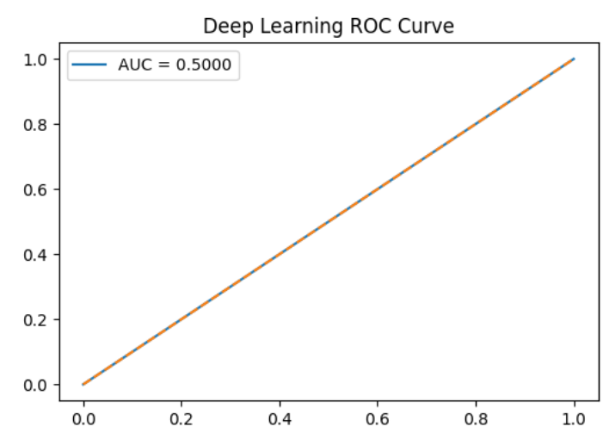

The ROC curve shows the performance of the Deep Learning model. With an AUC score of 0.5000, the model was unable to effectively distinguish between fraudulent and non-fraudulent transactions.

Figure 7:Histogram
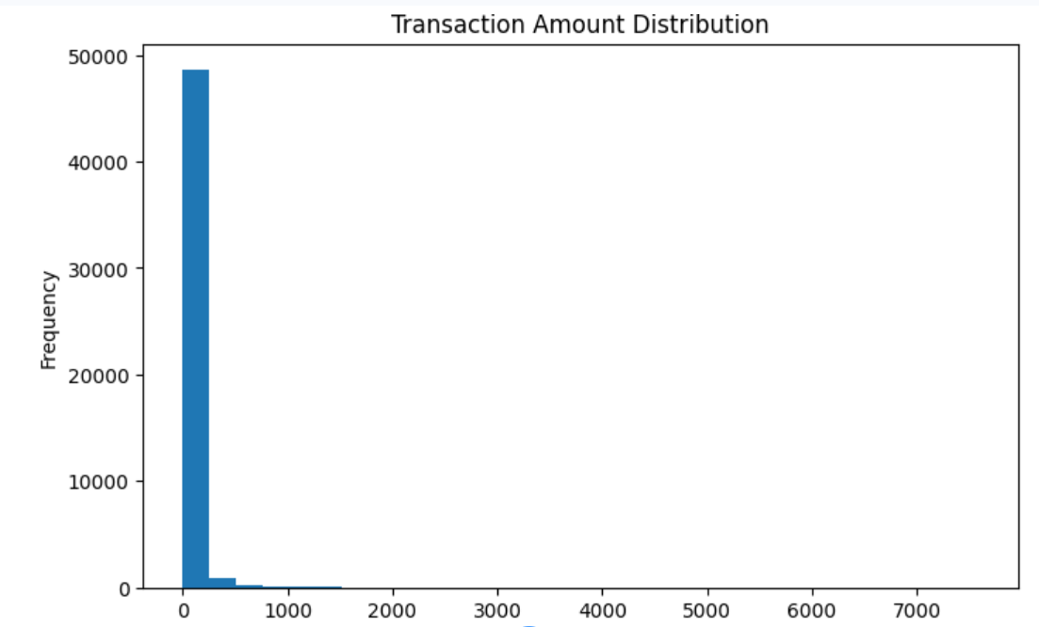
The histogram illustrates the distribution of transaction amounts in the dataset and highlights the variability in transaction values.
Figure 8: Radar Chart
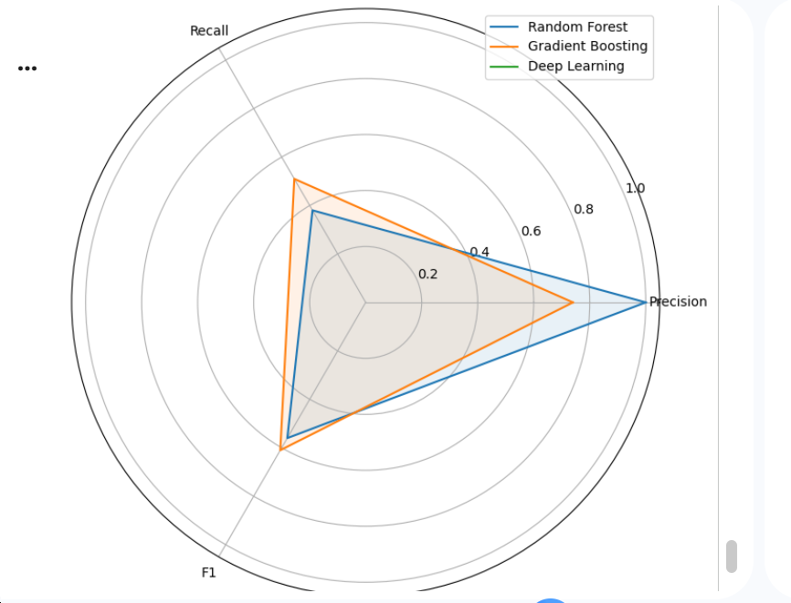
The radar chart compares the Precision, Recall, and F1-Score of the three models, providing a visual comparison of their performance.

Limitations and Future Work
The major limitation of this study is the severe class imbalance present in the dataset, which negatively affected the Deep Learning model. Additionally, only a subset of the dataset was used due to computational constraints.
Future work may include applying advanced balancing techniques such as SMOTE, experimenting with LSTM architectures, and deploying the system using cloud-based infrastructure.

Conclusion
This study developed and evaluated a credit card fraud detection system using Random Forest, Gradient Boosting, and Deep Learning models. Experimental results showed that Gradient Boosting achieved the best fraud detection performance. The developed Flask-based application demonstrates the practical deployment of machine learning models for fraud detection. Future work may focus on advanced balancing techniques and deep learning architectures to further improve fraud detection performance.
A Flask-based web application was developed and successfully integrated with the trained fraud detection models to demonstrate practical deployment.
References
Alarfaj, F. K., Malik, I., Khan, H. U., Almusallam, N., Ramzan, M., & Ahmed, M. (2022). Credit card fraud detection using state-of-the-art machine learning and deep learning algorithms. IEEE Access, 10, 39700–39715. https://doi.org/10.1109/ACCESS.2022.3166891

Al-Maari, A. A., & Abdulnabi, M. (2023). Credit card fraud transaction detection using a hybrid machine learning model. In Proceedings of the IEEE 21st Student Conference on Research and Development (SCOReD) (pp. 119–123). IEEE.

Abadi, M., Barham, P., Chen, J., Chen, Z., Davis, A., Dean, J., ... Zheng, X. (2016). TensorFlow: A system for large-scale machine learning. In Proceedings of the 12th USENIX Symposium on Operating Systems Design and Implementation (pp. 265–283).

Bin Sulaiman, R., Schetinin, V., & Sant, P. (2022). Review of machine learning approach on credit card fraud detection. Human-Centric Intelligent Systems, 2, 55–68. https://doi.org/10.1007/s44230-022-00004-0

Benchaji, I., Douzi, S., El Ouahidi, B., et al. (2021). Enhanced credit card fraud detection based on attention mechanism and LSTM deep model. Journal of Big Data, 8, 151. https://doi.org/10.1186/s40537-021-00541-8

Bhattacharyya, S., Jha, S., Tharakunnel, K., & Westland, J. C. (2011). Data mining for credit card fraud: A comparative study. Decision Support Systems, 50(3), 602–613. https://doi.org/10.1016/j.dss.2010.08.008

Breiman, L. (2001). Random forests. Machine Learning, 45(1), 5–32. https://doi.org/10.1023/A:1010933404324
Chawla, N. V., Bowyer, K. W., Hall, L. O., & Kegelmeyer, W. P. (2002). SMOTE: Synthetic minority over-sampling technique. Journal of Artificial Intelligence Research, 16, 321–357. https://doi.org/10.1613/jair.953

Chen, T., & Guestrin, C. (2016). XGBoost: A scalable tree boosting system. In Proceedings of the 22nd ACM SIGKDD International Conference on Knowledge Discovery and Data Mining (pp. 785–794). https://doi.org/10.1145/2939672.2939785

Dal Pozzolo, A., Boracchi, G., Caelen, O., Alippi, C., & Bontempi, G. (2018). Credit card fraud detection: A realistic modeling and a novel learning strategy. IEEE Transactions on Neural Networks and Learning Systems, 29(8), 3784–3797. https://doi.org/10.1109/TNNLS.2017.2736643

Dal Pozzolo, A., Caelen, O., Johnson, R. A., & Bontempi, G. (2015). Calibrating probability with undersampling for unbalanced classification. In 2015 IEEE Symposium Series on Computational Intelligence (pp. 159–166). https://doi.org/10.1109/SSCI.2015.33

Dharma, B., & Latha, D. (2025). Fraud detection in credit card transactional data using hybrid machine learning algorithm. In Proceedings of the 6th International Conference on Mobile Computing and Sustainable Informatics (ICMCSI) (pp. 213–218). IEEE. https://doi.org/10.1109/ICMCSI64620.2025.10883549
El Hlouli, F. Z., Riffi, J., Mahraz, M. A., Yahyaouy, A., El Fazazy, K., & Tairi, H. (2024). Credit card fraud detection: Addressing imbalanced datasets with a multi-phase approach. SN Computer Science, 5, Article 173. https://doi.org/10.1007/s42979-023-02559-6

Esenogho, E., Mienye, I. D., Swart, T. G., Aruleba, K., & Obaido, G. (2022). A neural network ensemble with feature engineering for improved credit card fraud detection. IEEE Access, 10, 16400–16407. https://doi.org/10.1109/ACCESS.2022.3148298

Freund, Y., & Schapire, R. E. (1997). A decision-theoretic generalization of on-line learning and an application to boosting. Journal of Computer and System Sciences, 55(1), 119–139. https://doi.org/10.1006/jcss.1997.1504

Friedman, J. H. (2001). Greedy function approximation: A gradient boosting machine. Annals of Statistics, 29(5), 1189–1232. https://doi.org/10.1214/aos/1013203451

Gandhar, A., Gupta, K., Pandey, A. K., et al. (2024). Fraud detection using machine learning and deep learning. SN Computer Science, 5, 453. https://doi.org/10.1007/s42979-024-02772-x

Goodfellow, I., Bengio, Y., & Courville, A. (2016). Deep learning. MIT Press. https://www.deeplearningbook.org/

Hemdan, E. E. D., & Manjaiah, D. H. (2022). Anomaly credit card fraud detection using deep learning. In D. P. Acharjya, A. Mitra, & N. Zaman (Eds.), Deep learning in data analytics (Studies in Big Data, Vol. 91, pp. 277–301). Springer. https://doi.org/10.1007/978-3-030-75855-4_12
Hemanth, K., Virat, K. S., Rohith, M. D., Reddy, K. V. P., Selv, A. S., & S. P. S. (2025). Credit card fraud detection using machine learning methods. In Proceedings of the Emerging Technologies for Intelligent Systems (ETIS) (pp. 1–6). IEEE. https://doi.org/10.1109/ETIS64005.2025.10961927
Hochreiter, S., & Schmidhuber, J. (1997). Long short-term memory. Neural Computation, 9(8), 1735–1780. https://doi.org/10.1162/neco.1997.9.8.1735

Khalid, A. R., Owoh, N., Uthmani, O., Ashawa, M., Osamor, J., & Adejoh, J. (2024). Enhancing credit card fraud detection: An ensemble machine learning approach. Big Data and Cognitive Computing, 8(1), Article 6. https://doi.org/10.3390/bdcc8010006

Mienye, I. D., & Jere, N. (2024). Deep learning for credit card fraud detection: A review of algorithms, challenges, and solutions. IEEE Access, 12, 96893–96910. https://doi.org/10.1109/ACCESS.2024.3426955

Patni, J. C., et al. (2025). Machine learning approach for credit card fraud detection: A comprehensive analysis. In Proceedings of the 4th OPJU International Technology Conference (OTCON) on Smart Computing for Innovation and Advancement in Industry 5.0 (pp. 1–5). IEEE. https://doi.org/10.1109/OTCON65728.2025.11071089
Pedregosa, F., Varoquaux, G., Gramfort, A., Michel, V., Thirion, B., Grisel, O., ... Duchesnay, É. (2011). Scikit-learn: Machine learning in Python. Journal of Machine Learning Research, 12, 2825–2830.

Raj, S. B. E., & Portia, A. A. (2011). Analysis on credit card fraud detection methods. In Proceedings of the 2011 International Conference on Computer, Communication and Electrical Technology (ICCCET) (pp. 152–156). IEEE. https://doi.org/10.1109/ICCCET.2011.5762457
Raghavan, P., & Gayar, N. E. (2019). Fraud detection using machine learning and deep learning. In Proceedings of the 2019 International Conference on Computational Intelligence and Knowledge Economy (ICCIKE) (pp. 334–339). IEEE. https://doi.org/10.1109/ICCIKE47802.2019.9004231

Singh, A., & Jain, A. (2022). An efficient credit card fraud detection approach using cost-sensitive weak learner with imbalanced dataset. Computational Intelligence, 38(6), 2035–2055. https://doi.org/10.1111/coin.12555
Shetty, A. V., Dcunha, C. J., Deepthi, D., Bangera, D., & Sreekantha, D. K. (2025). FraudGuard: Advancing credit card fraud detection with machine learning benchmarks. In Proceedings of the International Conference on Artificial Intelligence and Data Engineering (AIDE) (pp. 326–332). IEEE. https://doi.org/10.1109/AIDE64228.2025.10986880
Zhang, Y.-F., Lu, H.-L., Lin, H.-F., Qiao, X.-C., & Zheng, H. (2022). The optimized anomaly detection models based on an approach of dealing with imbalanced dataset for credit card fraud detection. Mobile Information Systems, 2022, Article 8027903. https://doi.org/10.1155/2022/8027903

